MAGONDE VIMBAI magondevimbai5@gmail.com
Cell:+447394340186
Whatsapp: +447394340186
84Penlon place Abingdon ,
Oxfordshire
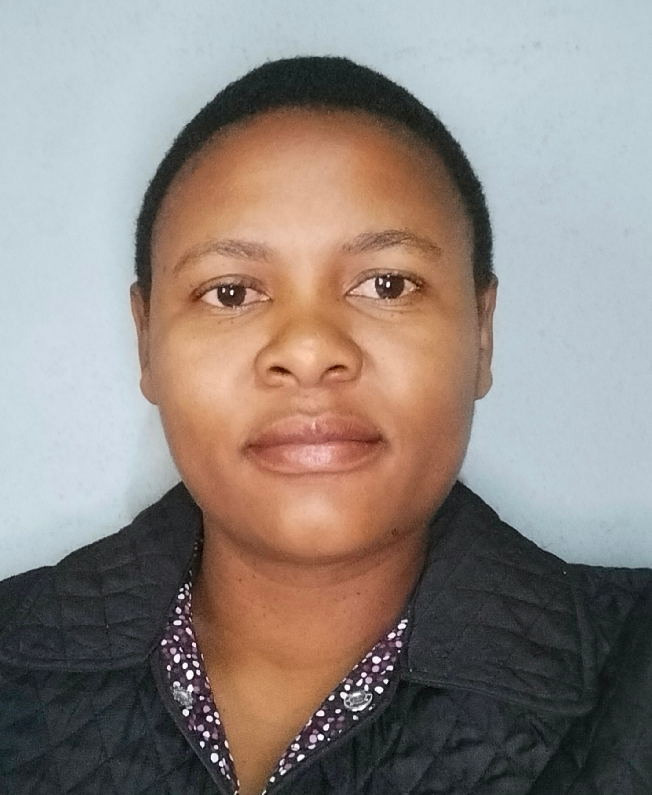

OBJECTIVE
A hard-working professional who has a genuine desire to help people of all ages.I am also experienced in Early childhood development and developing a level of care that is unique to every situation, and is greatly helped in doing this by my ability to quickly build up relationships with clients and thereby gain a greater awareness of their practical and social needs.I have the ability to successfully encourage clients to be involved and independent as much as possible.
SKILL
GOOD TEAM PLAYER
REPORT WRITING
ADMINISTRATIVE SKILLS

MEAL PREPERATION
GREAT REPORTING AND COMMUNICATION SKILLS

ASSISTING VULNERABLE INDIVIDUALS
SAFEGUARD ADULTS AND CHILDREN CHILDREN

EDUCATION
NGUNDU HIGH SCHOOL MASVINGO ZIMBABWE 2006
O LEVEL ZIMSEC
5 OLEVEL PASSES INCLUDING MATHS AND ENGLISH

BONDOLFI TEACHERS COLLEGE 2020
DIPLOMA IN EDUCATION
SPECIALIST IN EARLY CHILDHOOD DEVELOPMENT

St JOHN AMBULANCE 2022
NURSE AIDE CERTIFICATE

EXPERIENCE
MADZIVIRE PRIMARY SCHOOL 2019
EARLY CHILDHOOD TEACHER
2019-2020

SHEKHINAH HOME OF HOPE 2021-DATE
EARLY CHILDHOOD DEVELOPMENT COORDINATOR
# Caring for children and providing proper education
# Creating a conducive environment for children
# Admission work
# Developing children physically, emotionally and cognitively.

Nurse Aide trainee 2022
Mt SELINDA MISSION HOSPITAL
CHIPINGE
# Providing personal assistance to elderly patients including bathing, oral care, dressing and feeding
# Treating patients with empathy, compassion and respect.
# Recording vital signs such as temperature, blood pressure and pulse
# Building trusting relationships with a wide range of patients.
# Carrying out pre and post-operative checks.
# Maintaining cleanliness of the ward by promoting a safe and conducive environment.
# Daily errands such as collecting surgical and general stores from the pharmacy.
# Sending dirty packs to and collecting sterile packs from CSSD.
# Shrouding
# Emptying and changing urine bags.
# Sluicing of soiled linen.
# Bed making, turning and positioning bed ridden patients regularly.
# Damp dusting.

ACTIVITIES
√VOLUNTEER √COOKING √PHYSICAL ACTIVITIES √READING
REFERENCE
SHEKHINAH HOME OF HOPE BONDOLFI TEACHERS’COLLEGE
TEACHER IN CHARGE THE PRINCIPAL
JEAN MSEMA MR. K.K CHITSAMA
msemajean3105@gmail.com CELL: +263 77 536 5436

Mt SELINDA MISSION HOSPITAL
MEDICAL SUPERITENDENT
Dr LOVEMORE SITHOLE
E mail :sitholelovemore3@gmail.com

ADDITIONAL INFORMATION
#Valid driver's license.
#Police clearance.
#Covid 19 Certificate.
#Good health and able to work all shifts.
#IELTS General UKVI certificate
#TB Test certificate
#Full DBS check

